A Peek into Wild Africa: Wildlife Sanctuary Management at the Kevin Richardson Foundation

Waking up every morning watching the giraffes wander through the bush and listening to the hyenas and jackals yelping in the night to each other isn’t a bad place to conduct a camera trap research project. I am in my second month at the Kevin Richardson Sanctuary. Starting off every morning at 5am checking the the sanctuary camera traps and post in the group chat. Then head over to the fridge for meat preparation for the lions, leopards and hyenas. Cutting up cow and horse limbs every morning with a machete really gets the blood flowing in the morning!

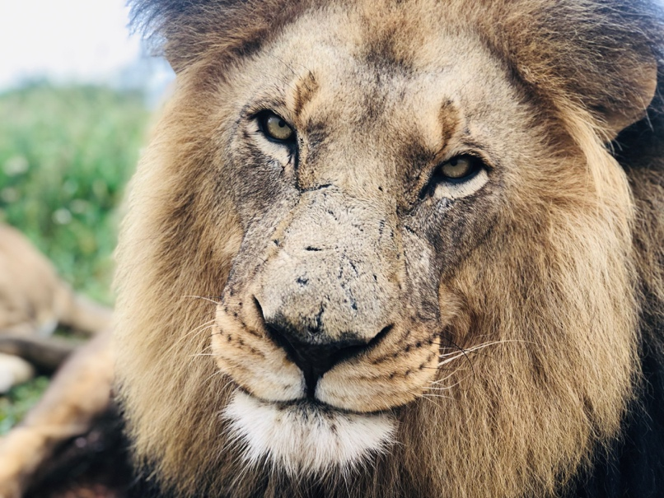
A lot of work goes into running a wildlife sanctuary. The Kevin Richardson Foundation believes in integrated conservation. The Sanctuary is home to twenty-six lions that were rescued from captive-breeding and cub-petting facilities. Kevin Richardson uses these rescued animals as part of an educational platform, to inform the world about canned hunting and the lion bone trade. Lion hunting is controversial, mostly on philosophical and ethical grounds. Canned hunting is the most extreme type of “Trophy Hunting”. These lions are bred on farms and are hand raised. Tourists will come thinking they are helping a conservation effort. They are told that these cubs were abandoned by their mothers.

My daily duties start off with food preparation, feeding, medication meat prep, enclosure feeding, weeding and meetings with Kevin Richardson for walk and talks. When cutting up the meat, I record the date and where the meat was sourced, in case one of the animals were to fall ill, we would be able to trace the food back to its source, in an attempt to avoid further problems. We tag the meat with the name of the animals in order to keep the feeding process organized. After feeding is done, we clean the night enclosures where the animals eat. First, we remove all of the bones and left over meat; we also scrub the night pens clean. Feeding day is every Wednesday and Saturday, beginning at around 5:00 a.m. to 11:00 or noon. I supervise the volunteers to teach them the daily tasks and walk them through the process, if they have any questions. Fencing duties require removal of the electrical wires from some of the enclosures and replacing it with new electrical wiring. This is important for management of the Sanctuary, because people from all over the world come to the Kevin Richardson Sanctuary with intentions of enjoying a wonderful experience. Having meetings with Mr. Richardson every other day to discuss events that are going to be occurring in the Sanctuary and jobs that need to be done helps me learn about the extensive management and responsibility that goes into managing and maintaining a successful wildlife sanctuary. Duties will vary throughout my two-month internship.

Yesterday was hands down the best day of my life. Olivia one of the lionesses needed to get spayed. I got to go into the truck where the vet was in the back with her and we drove to Pretoria where the vet clinic is located. I was fortunate enough to be able to be in the surgery room and see the whole procedure up close. The whole procedure took around 3 hours. After it was done we loaded her back into the truck and drove back to the sanctuary. The procedure went well! After we lifted her and put her in the night pen to recover for a while. Eventually all the female lions at the sanctuary will have the same surgery. The correct term for the surgery is called ovariohyasterectomy. Since Kevin does not breed any of his lions all of them are on birth control and when the birth control wears off that is when the rest will receive the surgery. The health benefits for spaying the lionesses are that it does cut down the risk of cancer and also balances out the hormone levels.

