Robinson
Foundation Art & Design

VISUAL DICTIONARY
As groups of three or four define the following terms as a group and by using the PowerPoint on CANVAS titled: E & P’s.

- find three visual examples* of each Element and principle (do not GOOGLE the terms to find images – use books or magazines provided or your own image archive from Visual Studies I).

*if a term has more than one example find a single image for each example (texture, balance are examples of this but there may be more)

Elements of Art & Principles of Design

Elements of Art:
- Line: quality (thick, thin, broken), implied line, actual line, linear networks: cross-contours, psychic line.
- Shape: a flattened, enclosed area.
- Texture: physical, visual (illusion), invented texture
- Value: contrast; value distribution (proportion of lights and darks)
- Color: Hue<Saturation<Value
plus WHITE=TINT
plus GREY=TONE
plus BLACK=SHADE
- Plane: 3-d form that has length and width but with minimal thickness
- Volume: refers to an enclosed area of 3-d space
- Mass: Mass: solid 3-d form
- Space: area within or around an area of substance: positive/negative, compression/expansion, activated, entering
- Light: can enhance or obscure, affect emotions, entice us to enter, create mystery, can even be sculptural medium
- Time / motion: actual and implied are two aspects of time.
Principles of Design
- Unity/variety: unity- similarity, oneness, togetherness, cohesion
variety- visual diversity to avoid an unintended monotonous composition and to hold the viewer’s interest.
- Balance: Symmetry/approximate symmetry: visual or actual equilibrium of two halves of a composition mirroring each other in size/shape and placement of elements of art.
Asymmetry: creates equilibrium among visual elements that do not mirror each other on either side of axis. (Depending, design can be quite dynamic or chaotic
Radial symmetry: equilibrium achieved by elements emanating from a point, usually the center of a composition
- Scale/Proportion scale-comparative size of an element of art or object in relation to other objects and expectations about what is normal. Ex. Human scale
proportion- relationship of the size of parts to each other and to the whole artifact or image
- Rhythm: sense of movement – regular, irregular, pattern, grid
- Emphasis: arrangements of elements of art to make some are the primary focus of a viewer’s attention

- Line-
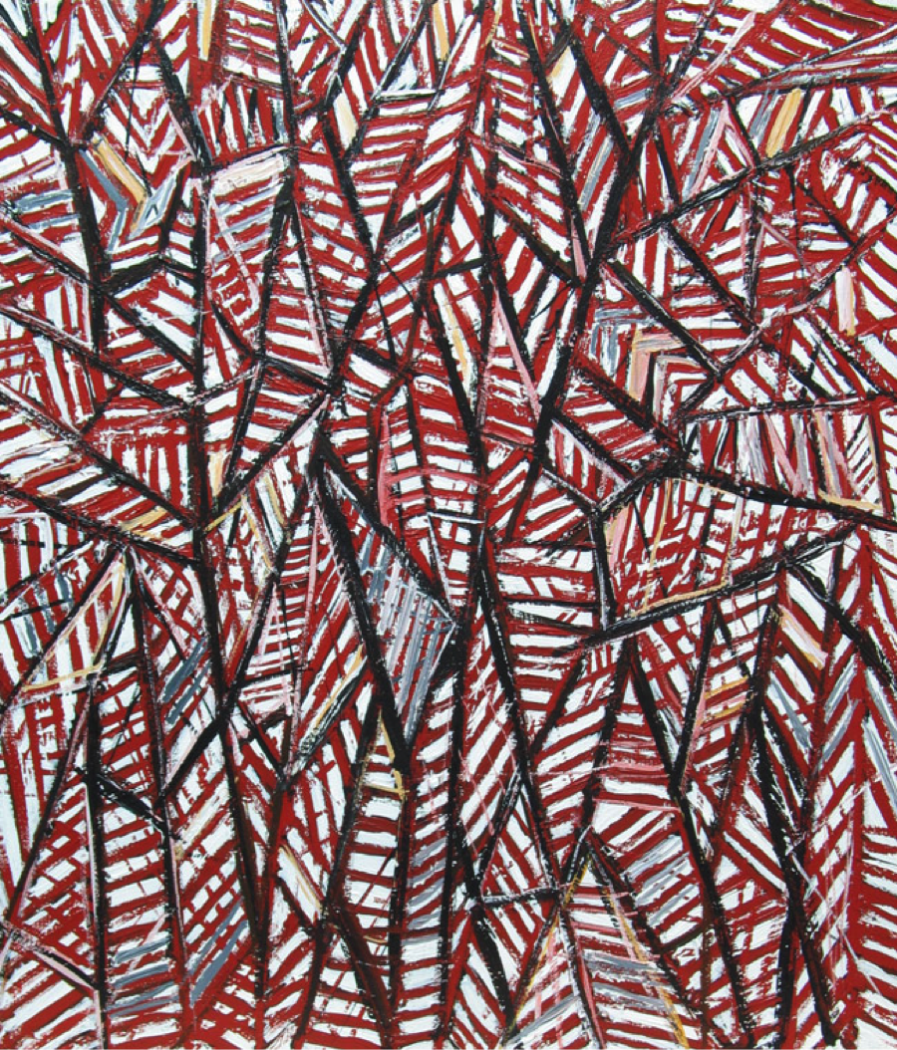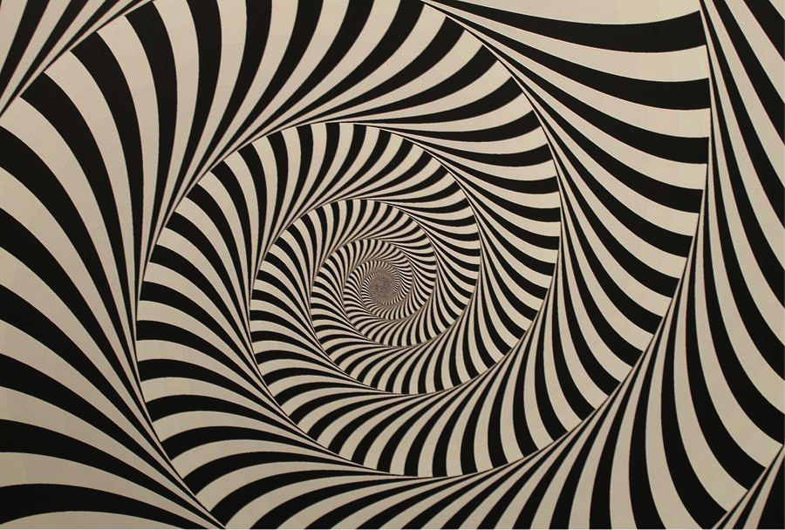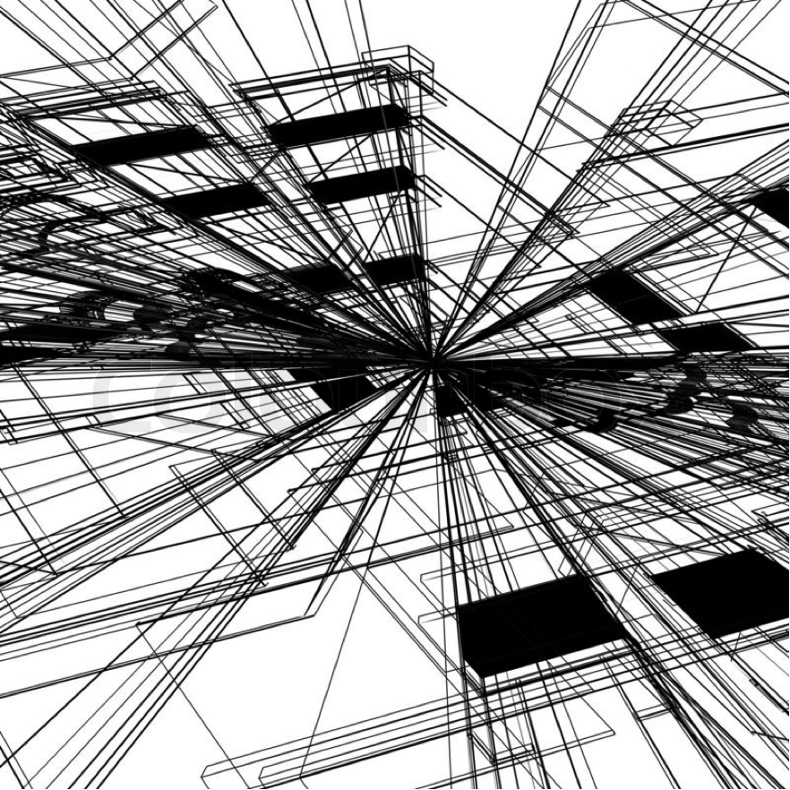
- Shape- 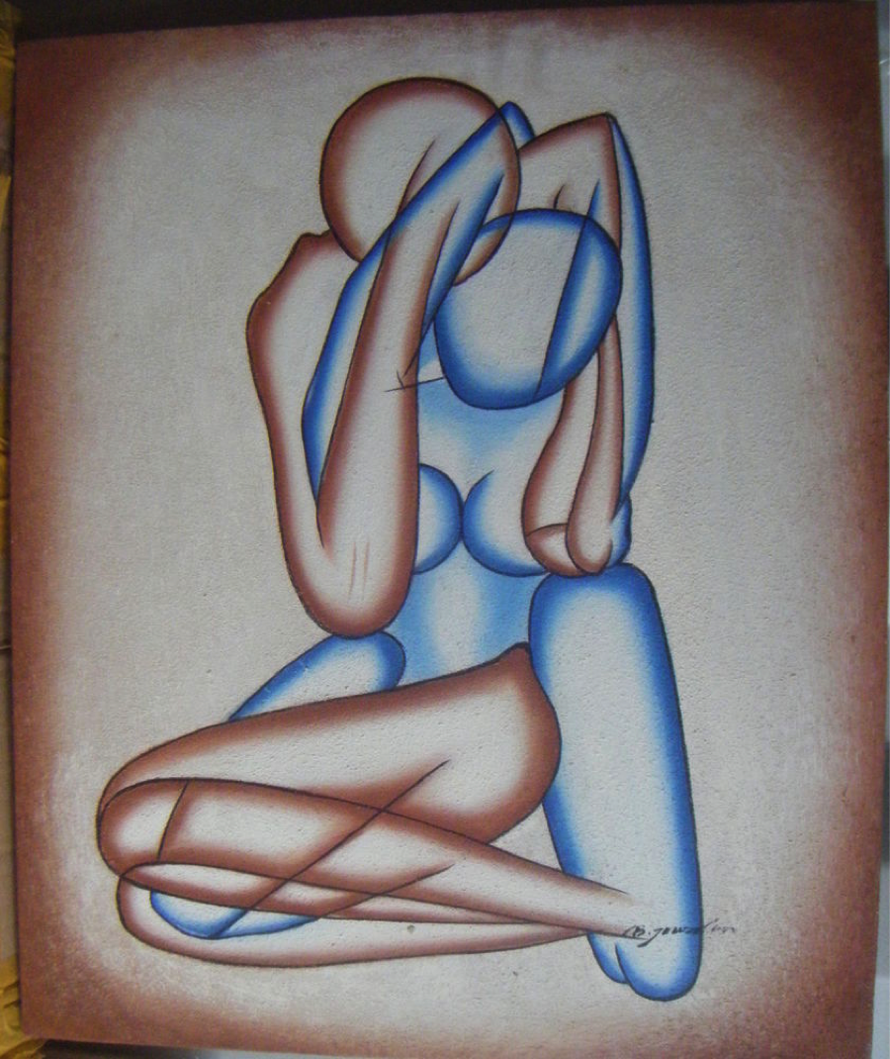
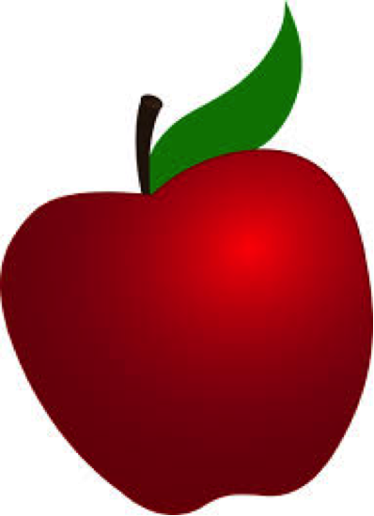
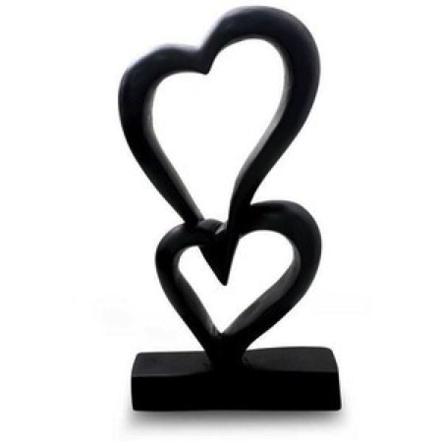
- Texture- 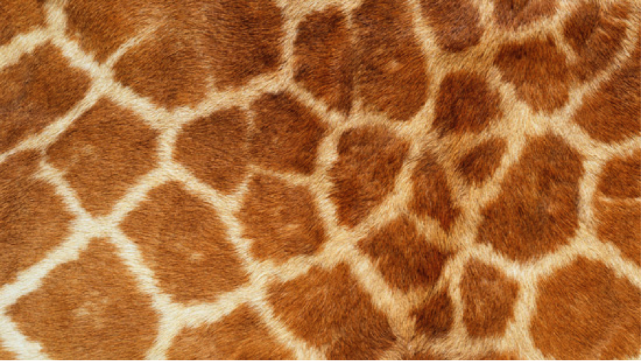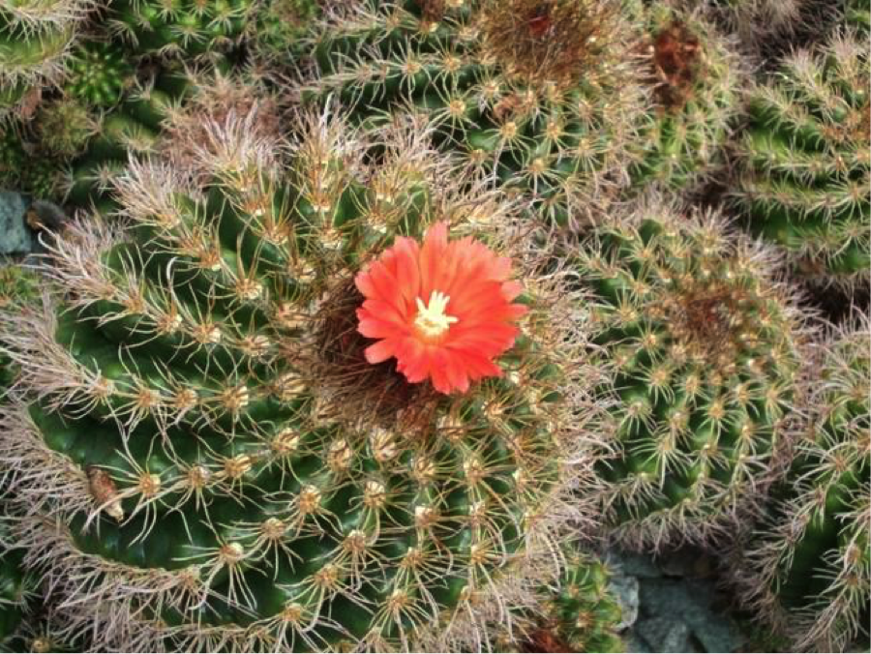
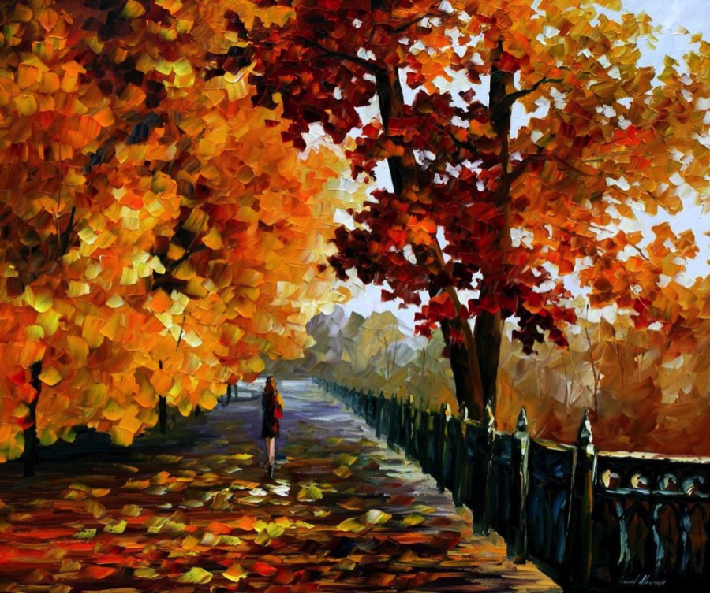
- Value- 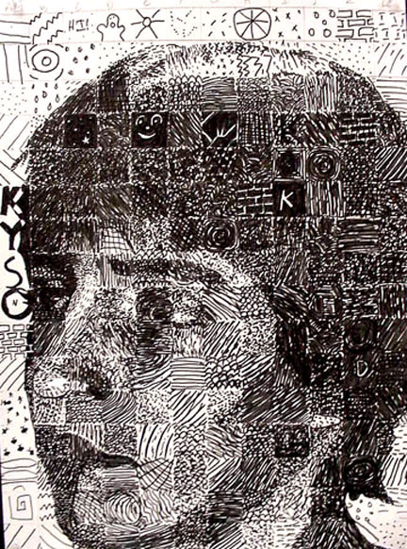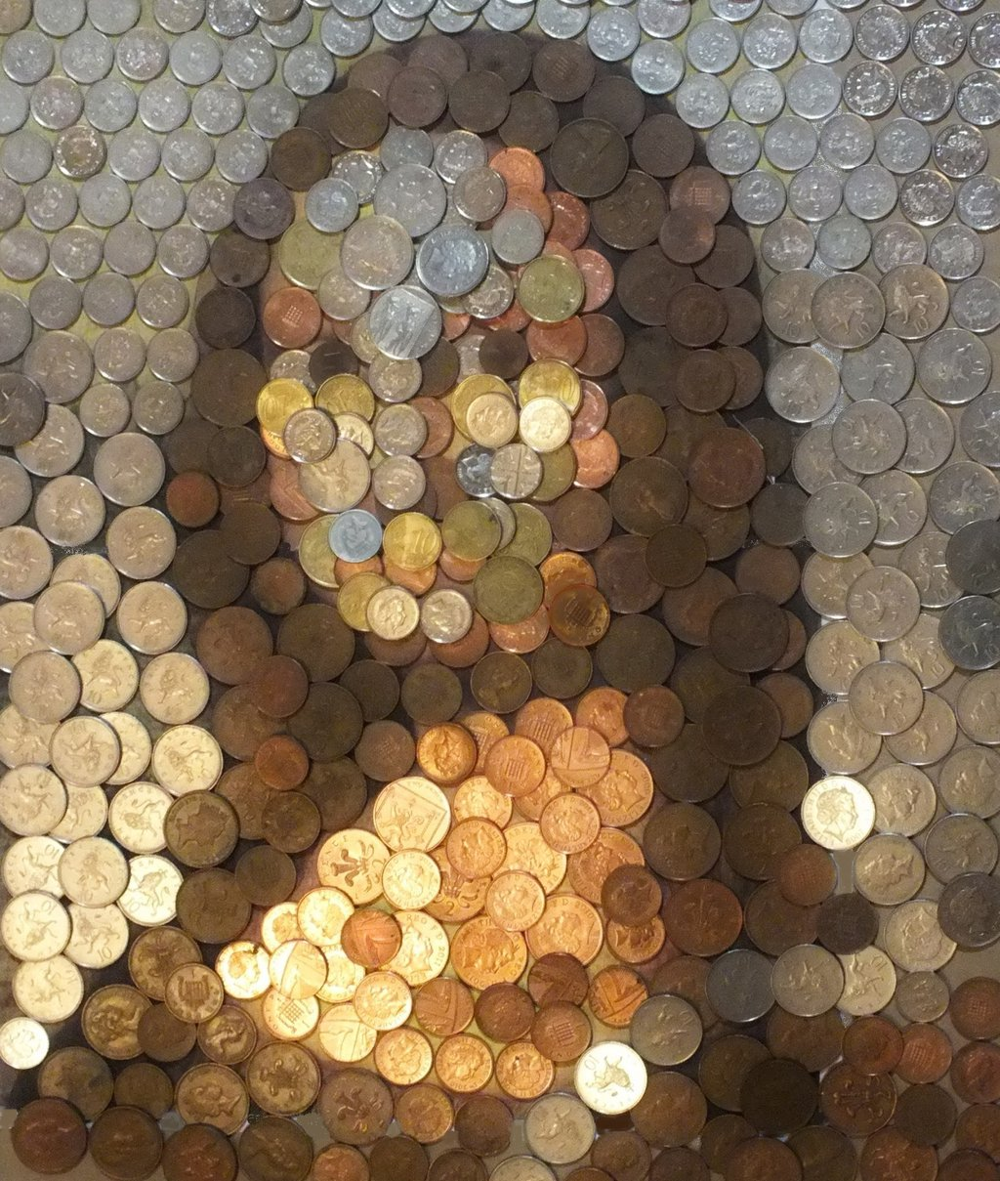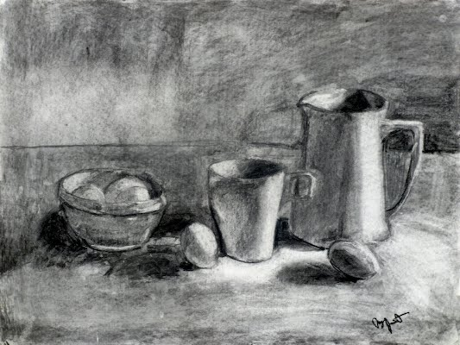

- Color- 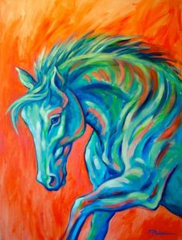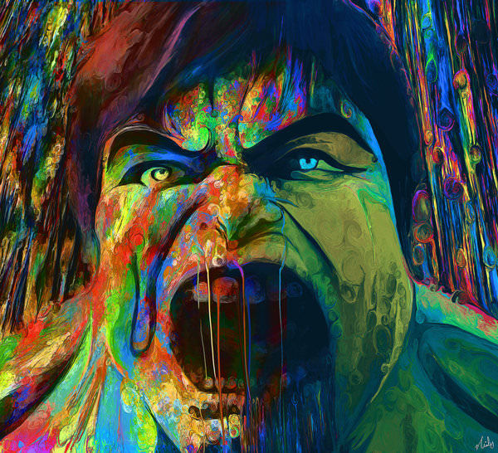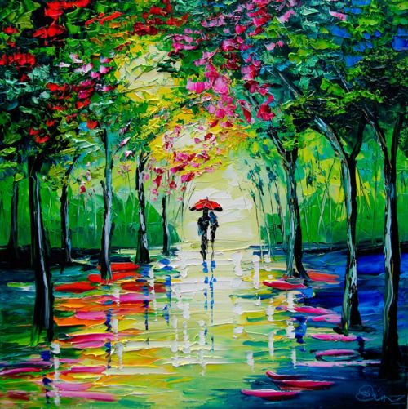
- Plane-
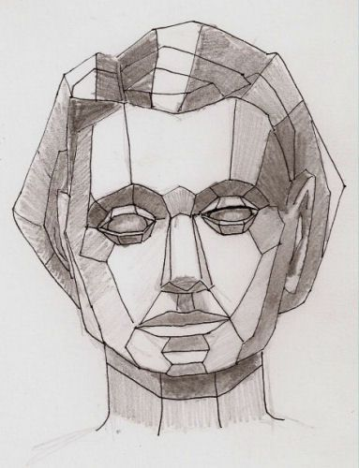
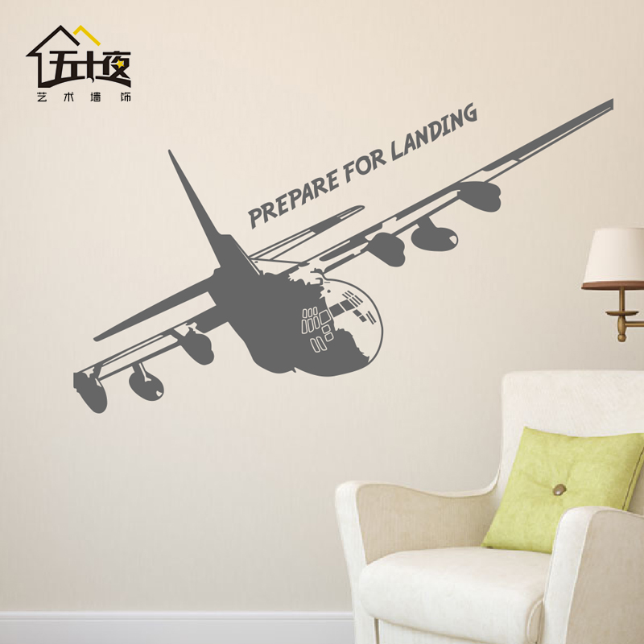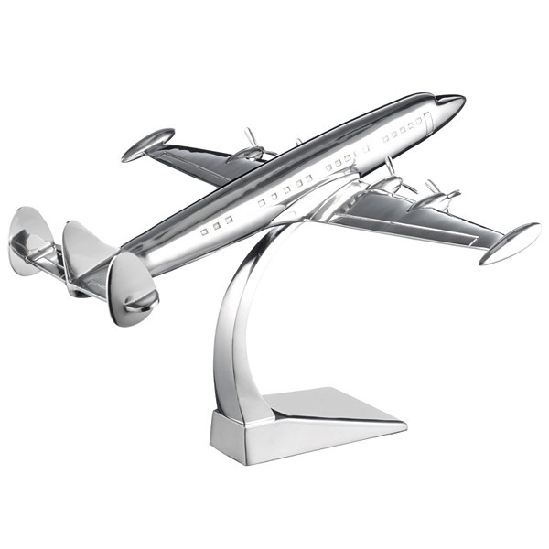

- Volume- 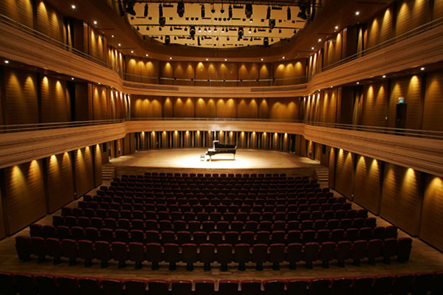
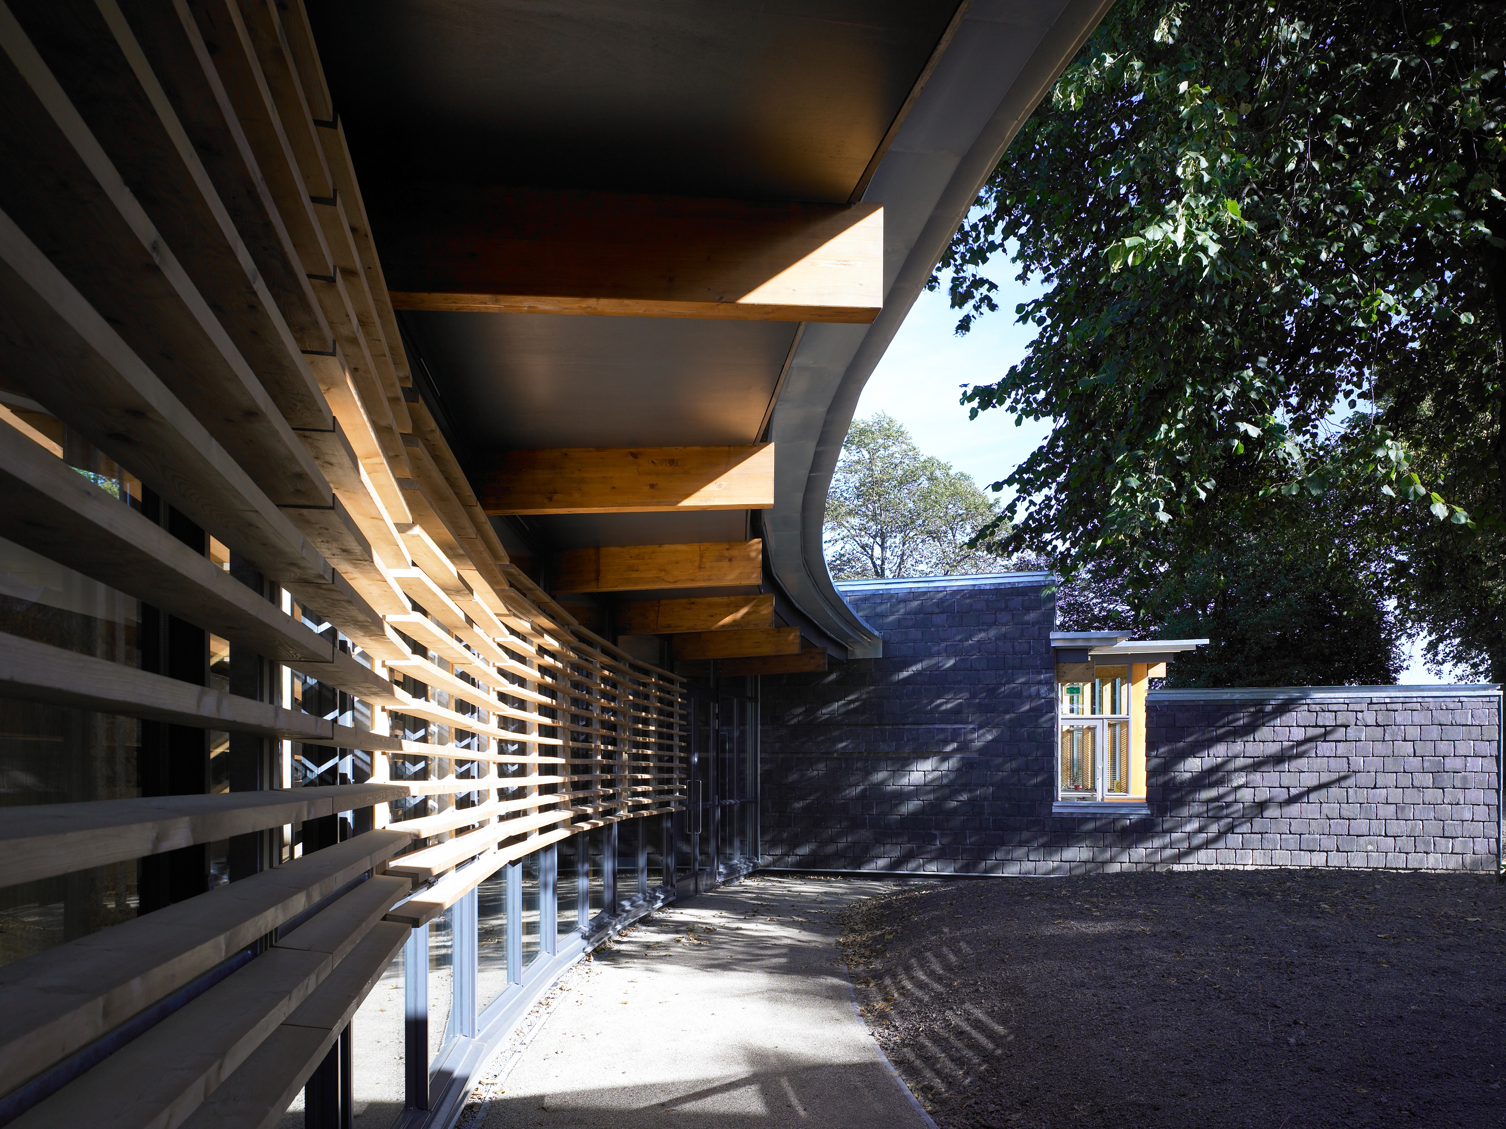
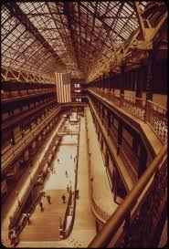

- Mass-
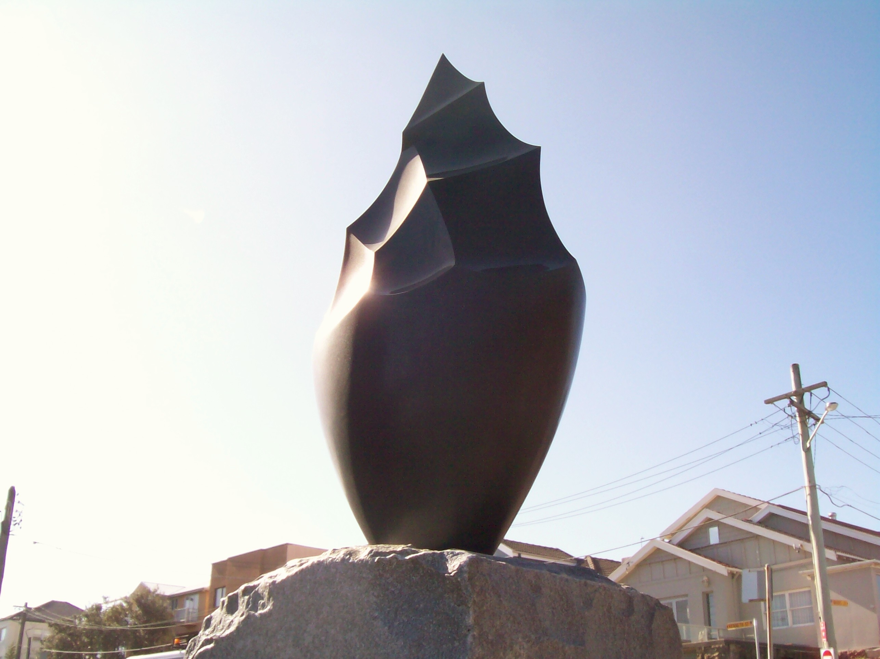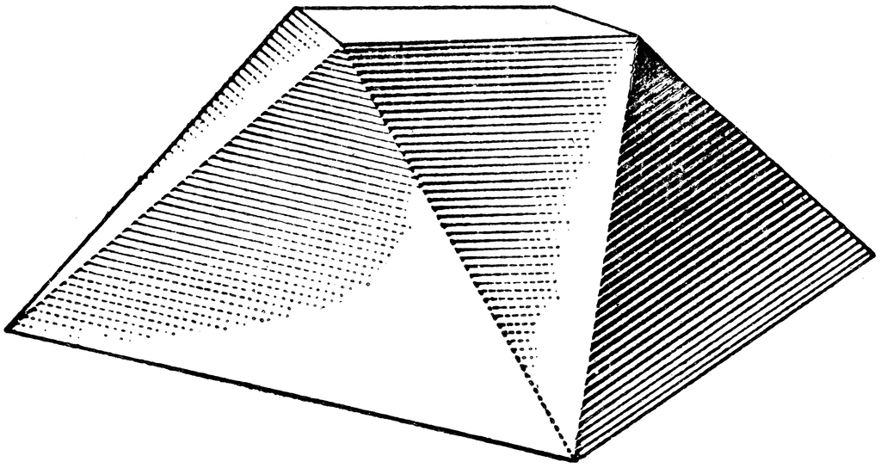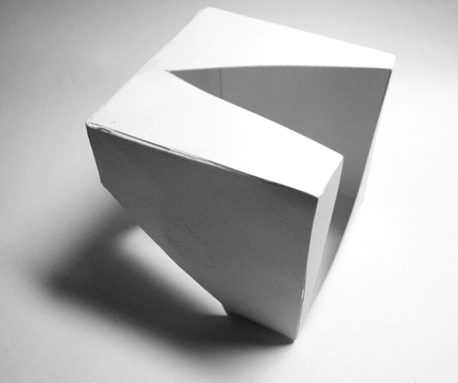
9.Space- 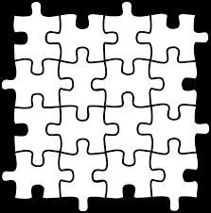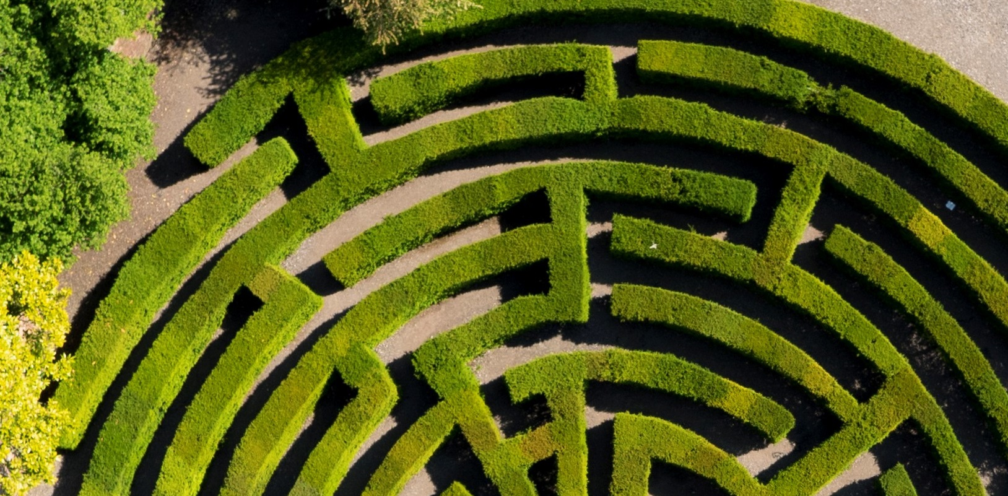
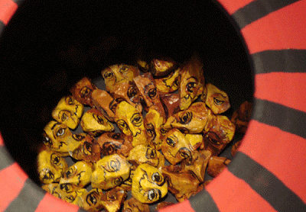
10.Light- 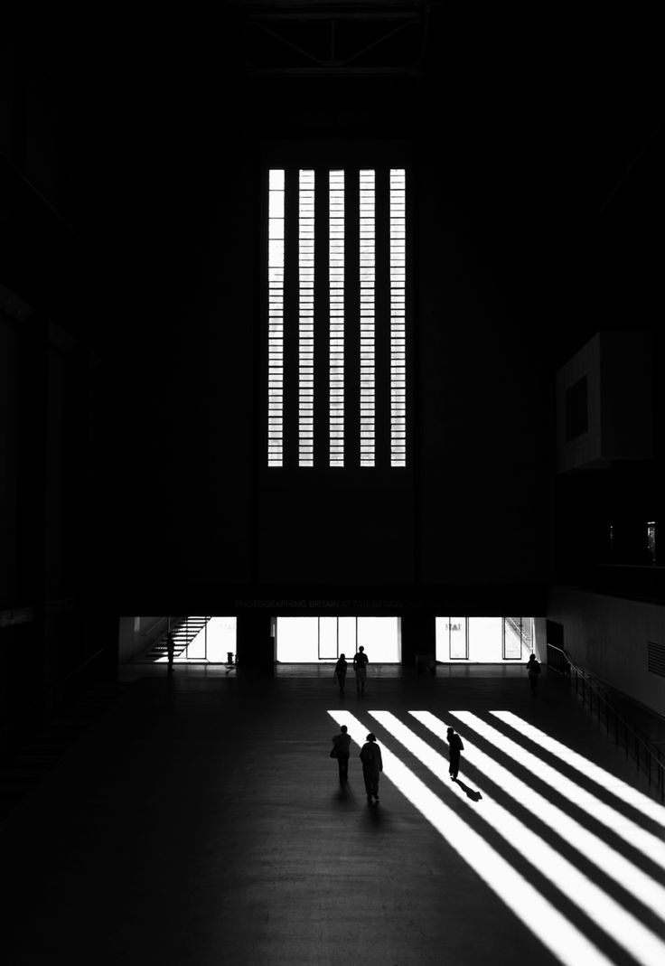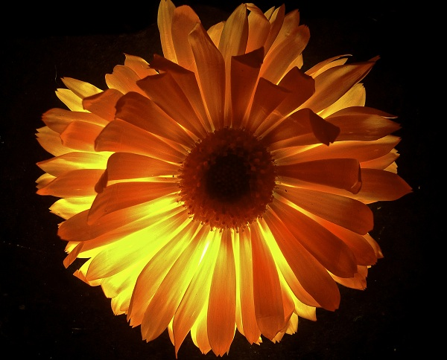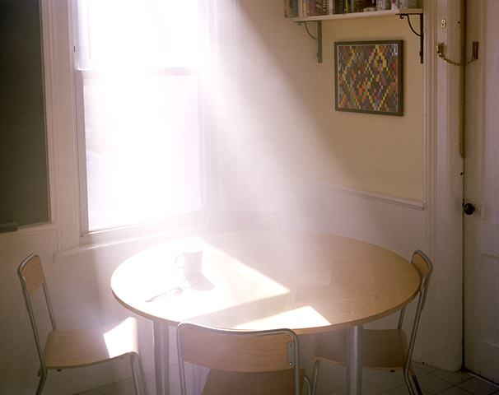

11.Time/Motion- 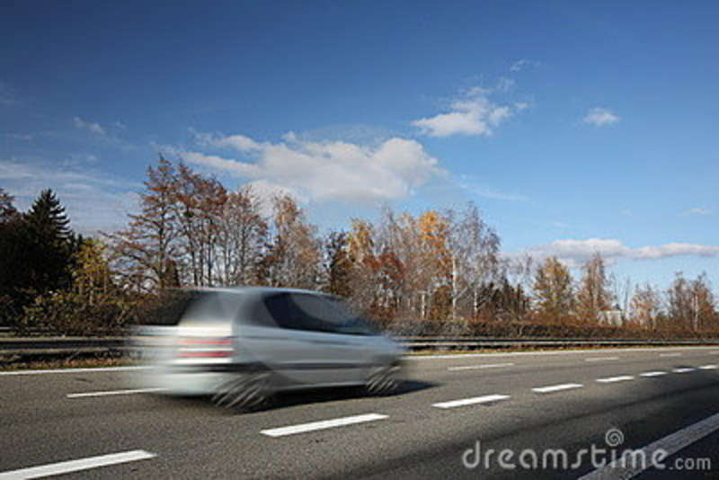
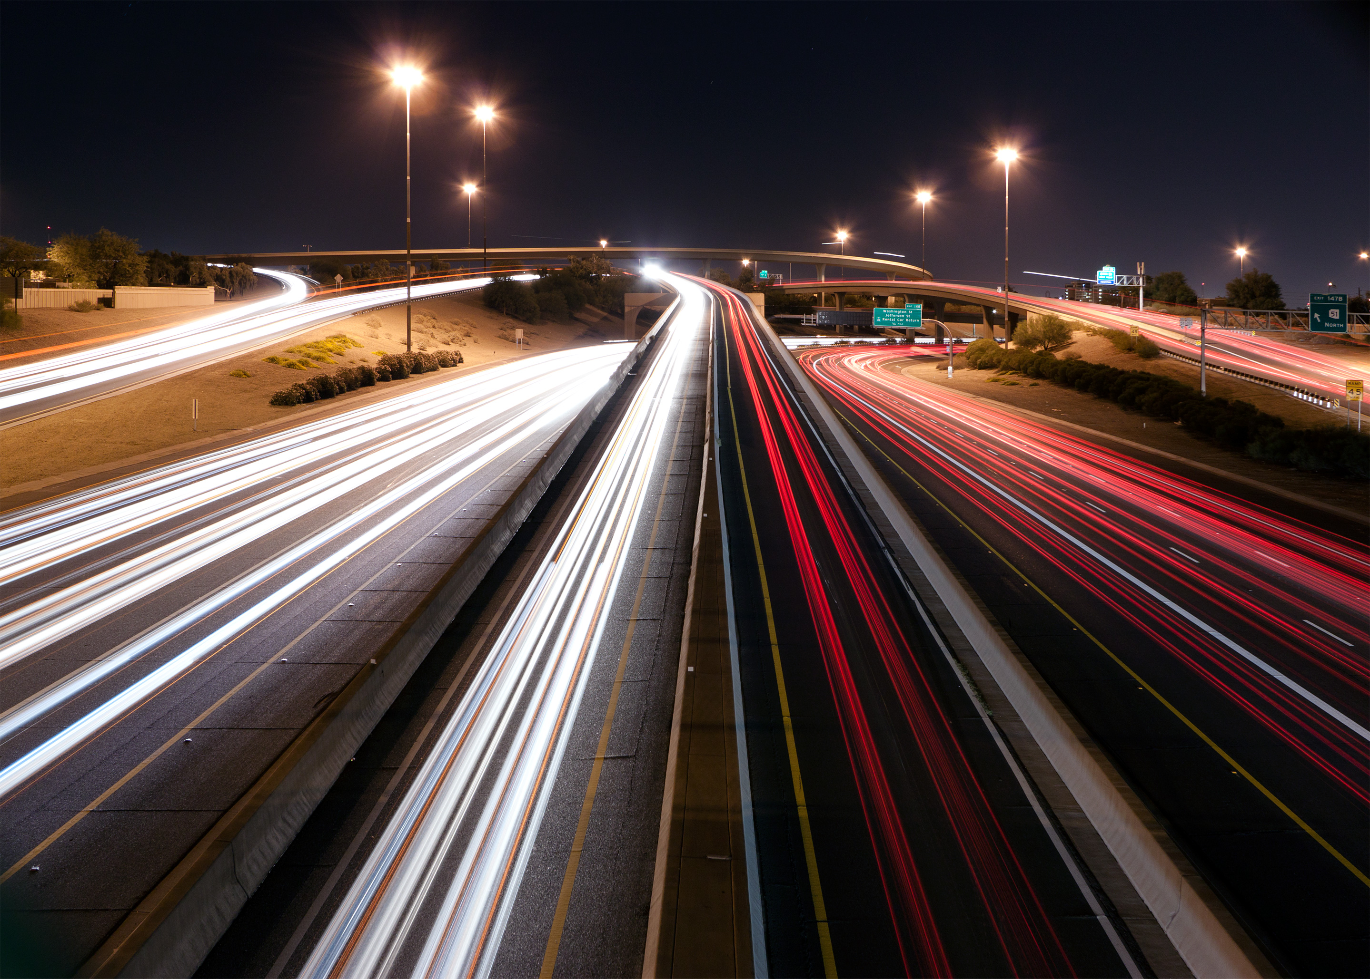


1. Unity/Variety-
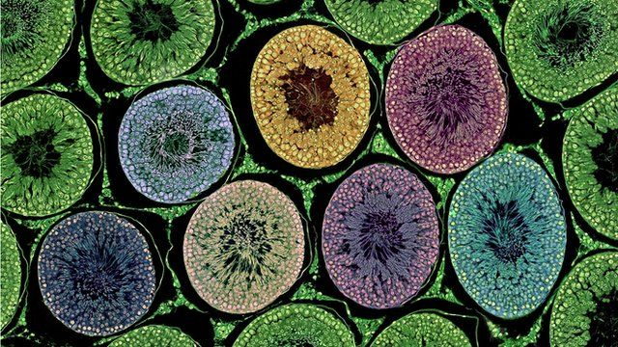
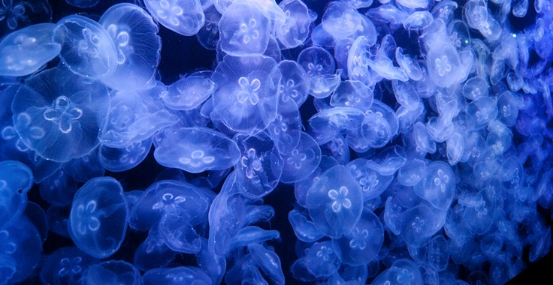

2. Balance-
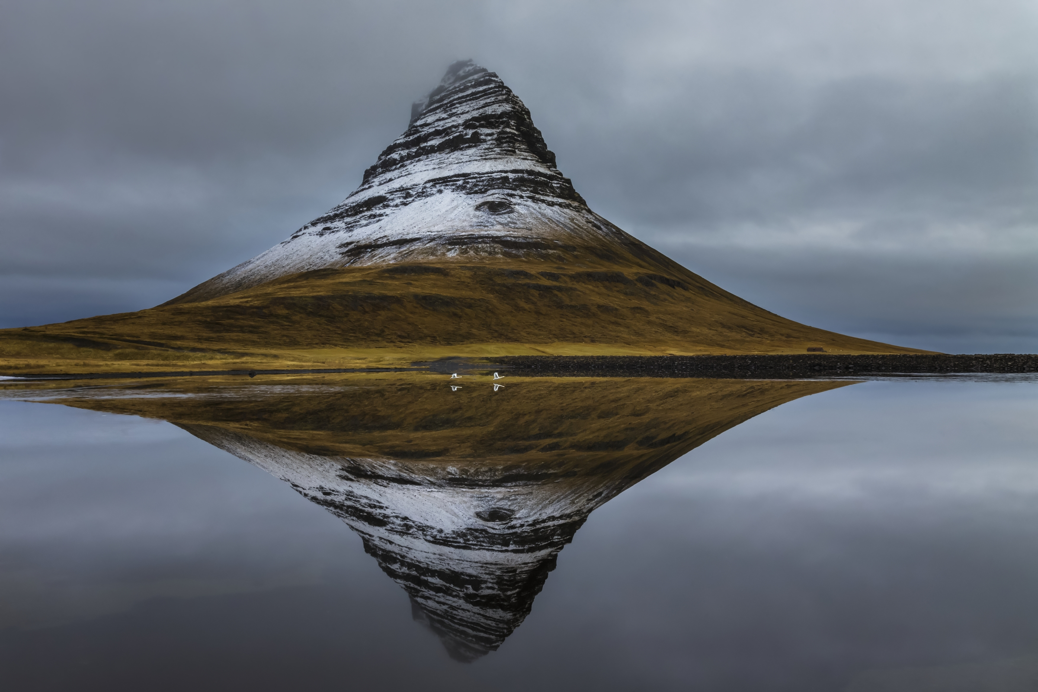
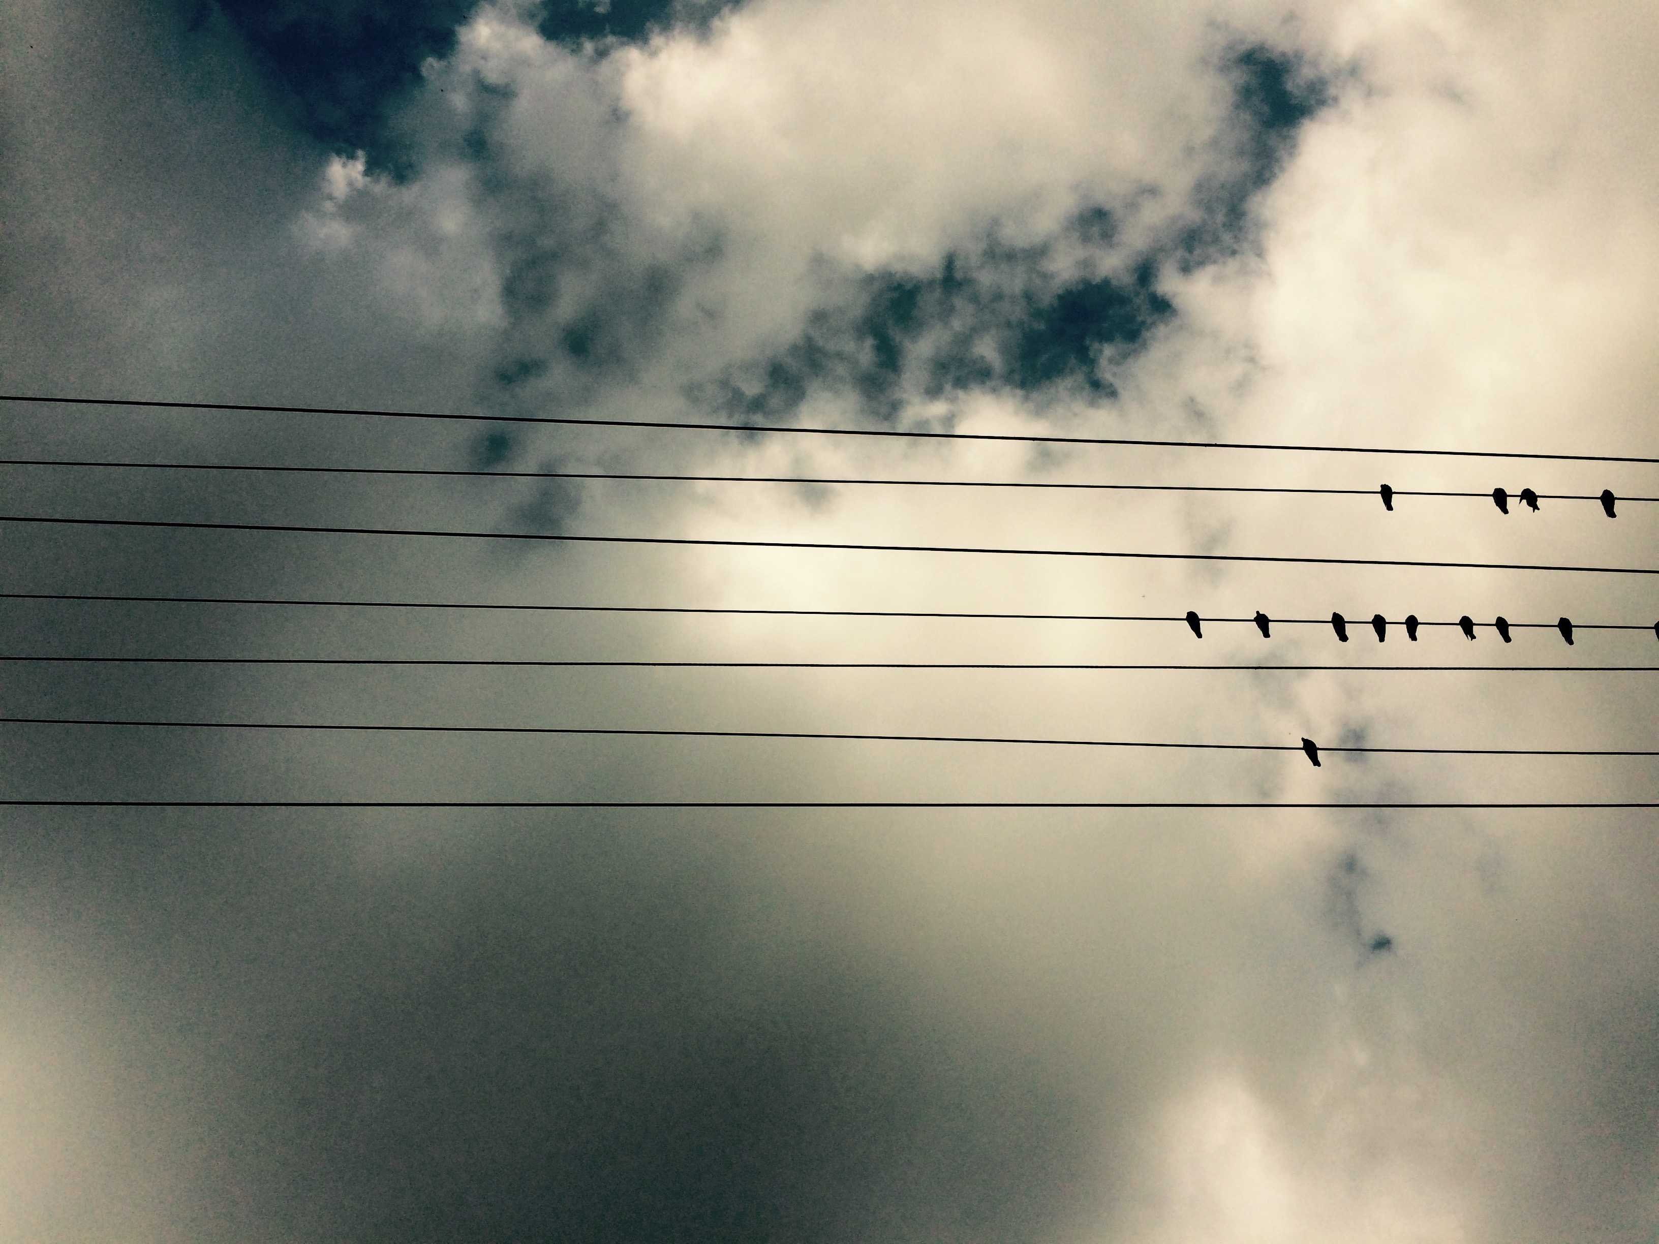

3. Scale/Proportion
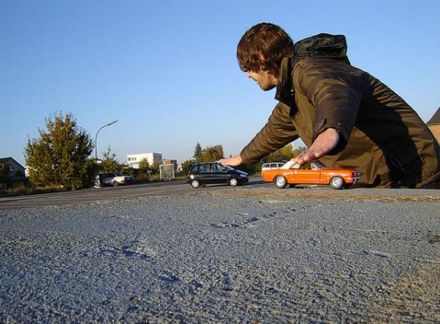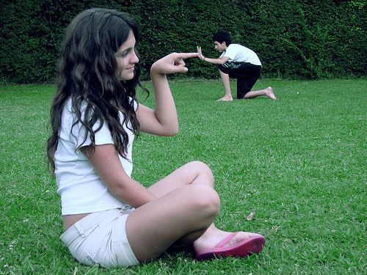

4. Rhythm-

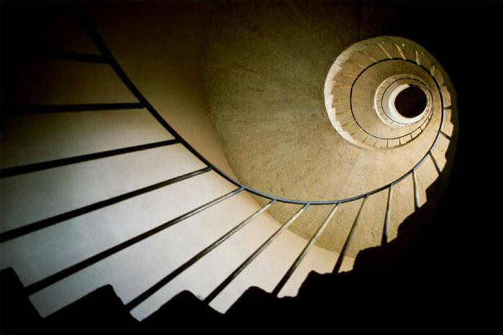
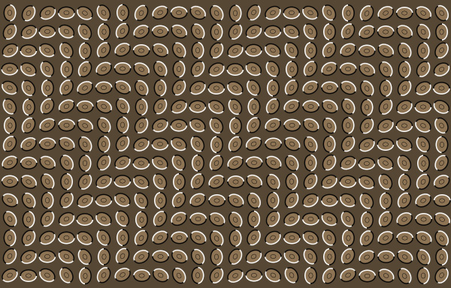

5. Emphasis-


